vs. 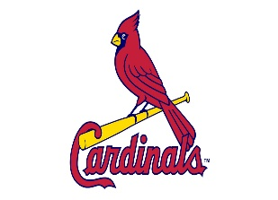

Rotary Day at the Ball Park
6:15 P.M., Saturday, July 29th

Saturday, July 29th is the date set for the 20th Rotary Family Day at the Ball Park. The Chicago Cubs will play the St. Louis Cardinals at Busch Stadium in St. Louis with a 6:15 P.M. game time. Tickets are $60 and $20 from each ticket sold will be returned to Rotary District 6490 clubs for literacy efforts. Tickets can be sold to anyone in your community; attendees do not need to be Rotarians. Please use the attached order form. Checks should be made payable to Rotary District 6460. Order forms and checks should be mailed to Racheal Fearday, 605 Flame Court, Effingham, IL 62401. She will mail tickets to you, upon receipt of your order form and check.

Rotary Family Day at the Ball Park*
Chicago Cubs vs. St. Louis Cardinals
Saturday, July 29, 2023 at 6:15 pm
20th Year Celebration at Busch Stadium in St. Louis

Name_______________________________ Rotary Club________________________________

Mailing Address_________________________________________________________________
City State Zip Code

Email Address_____________________________________Phone_(______)________________

Ticket Order:

__________ # of Tickets x $60.00 per ticket = _$___________Total Payment

Make check payable to Rotary 6460 Foundation, and mail to:

Mrs. Racheal Fearday
605 Flame Court
Effingham, IL 62401

*All seats will be in the left field loge and pavilion. $20.00 from each ticket purchased will be mailed back to your Rotary club to use for literacy projects.

